# Supplier Self-reported Cybersecurity Maturity Assessment

# Revision

Version 3

9/8/23 1:16 PM

# Author

Charles Wilson

# Abstract

This document details the process to be used to document the cybersecurity lifecycle processes currently used by a supplier.

# Group / Owner

Security / Systems Security Analyst

# Motivation

This document is motivated by the need to have adequate understanding of supplier cybersecurity lifecycle processes prior to selection for the development of security-related elements to be used in products subject to compliance with standards such as **ISO/SAE 21434** and **ISO 26262**.

# License

This work was created by **Motional** and is licensed under the **Creative Commons Attribution-Share Alike (CC-SA-4.0)** License.

[**https://creativecommons.org/licenses/by/4.0/legalcode**](https://creativecommons.org/licenses/by/4.0/legalcode)

# Overview

The **Supplier Self-reported Cybersecurity Maturity Assessment** is intended to establish the supplier’s cybersecurity processes and gauge their ability to perform the necessary activities. The baseline for the assessment is the AVCDL.

The following diagram illustrates the process to be used:

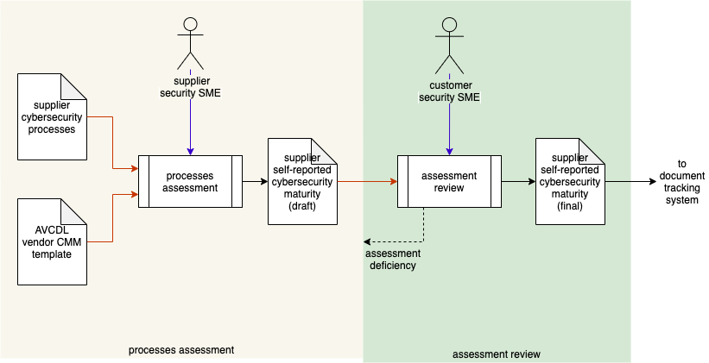

# Process

## Processes Assessment

|  |  |
| --- | --- |
| **Inputs** | Supplier cybersecurity processes  AVCDL vendor CMM template |
| **Outputs** | Supplier self-reported cybersecurity maturity (draft) |
| **Participants** | Supplier Security SME |

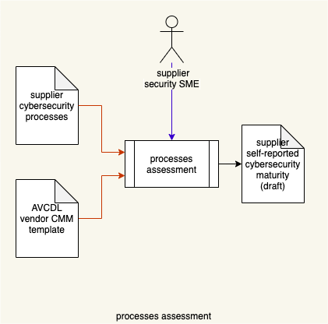

Using the **AVCDL vendor CMM template** **[2],** the supplier security SME creates a **supplier self-reported cybersecurity maturity (draft)** document, based on an understanding of the existing **supplier cybersecurity processes**.

## Assessment Review

|  |  |
| --- | --- |
| **Inputs** | Supplier self-reported cybersecurity maturity (draft) |
| **Outputs** | Supplier self-reported cybersecurity maturity (final) |
| **Participants** | Customer Security SME |

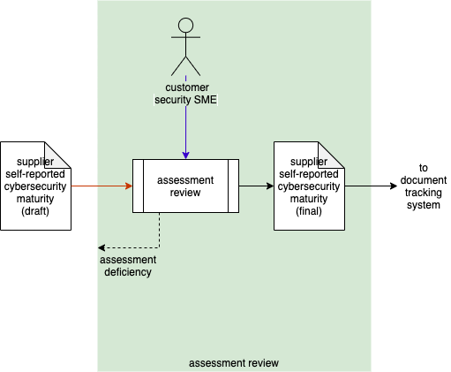

The customer security SME reviews the **supplier self-reported cybersecurity maturity (draft)**. If any deficiencies are identified, an **assessment deficiency** is reported to the supplier for resolution. If no deficiencies are identified, the **supplier self-reported cybersecurity maturity (final)** is entered into the document tracking system for future reference.

**Note:** Information in the **supplier self-reported cybersecurity maturity** document will be used in the creation of the **Cybersecurity Interface Agreement** **[3]**.

# References

1. **AVCDL (AVCDL primary document)**
2. **AVCDL vendor CMM template.xlsx (AVCDL template document)**
3. **Cybersecurity Interface Agreement (AVCDL secondary document)**
4. **Understanding Cybersecurity Interface Agreements (AVCDL secondary document)**